ZEBRA Image Access System
Srilekha Mudumbai, Kshitij Shah, Amit Sheth, Krishnan Parasuraman, Clemens Bertram
Large Scale Distributed Information Systems (LSDIS) Lab
Department of Computer Science, University of Georgia
http://lsdis.cs.uga.edu/
The ZEBRA system, which is part of the VisualHarness platform for managing heterogeneous data, supports three types of access to distributed image repositories: keyword based, attribute based, and image content based. A user can assign different weights (relative importance) to each of the three types, and within the last type of access, to each of the image properties.

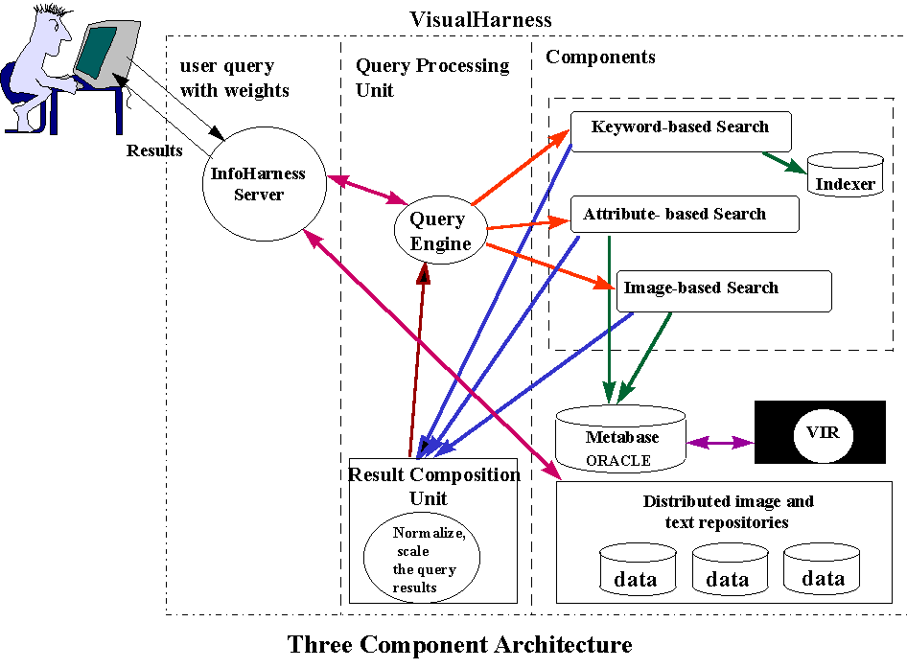
The Image based access component (IBAC) supports access based on computable image properties such as those based on spatial domain, frequency domain or statistical and structural analysis. However, it uses a novel black box approach of utilizing a Visual Information Retrieval (VIR) engine to compute corresponding metadata that is then independently managed in a relational database to provide query processing involving image features and information correlation. That is, we overcome the difficulties in using the feature vectors that are proprietary to a VIR engine, as we do not require any knowledge of the internal representation or format of the image feature used by a VIR engine. IBAC also gives the user an option of combining any of the image properties. Tests focusing on the quality of the results obtained using the black box approach, when compared to the results obtained by the VIR used by the black box approach, are encouraging. Furthermore, unlike VIRs, our metadata-based approach supports access to distributed repositories of images (in addition to text, semi-structured documents and structured databases).

